|  |  |  |  |  |  |
| --- | --- | --- | --- | --- | --- |
| Date | 23-Nov-22 | | | Tester Name | Shahabuddin Syed |
| Environment | Penfax - Test | | | Login used |  |
| Operating System | Windows | Version: | Update: | | |
| Software Used | Edge | Version: | Update: | | |
| Select Software | Version: | Update: | | |
| Release version | 22.4.1 | | | | |
| Title | M11.02 – Project Estimates | | | | |
| Test Type | Regression | | | | |
| Test Scenario | Non vested General 10 month member with different service types has low salary and age <35 | | | | |
|  |  | | | | |
| Expected Results |  | | | | |
| Pass/Fail | Pass | | | JIRA# | N/A |

Describe your steps with screenshots:

Login into Penfax application

Search for the member

Click on their stakeholder ID

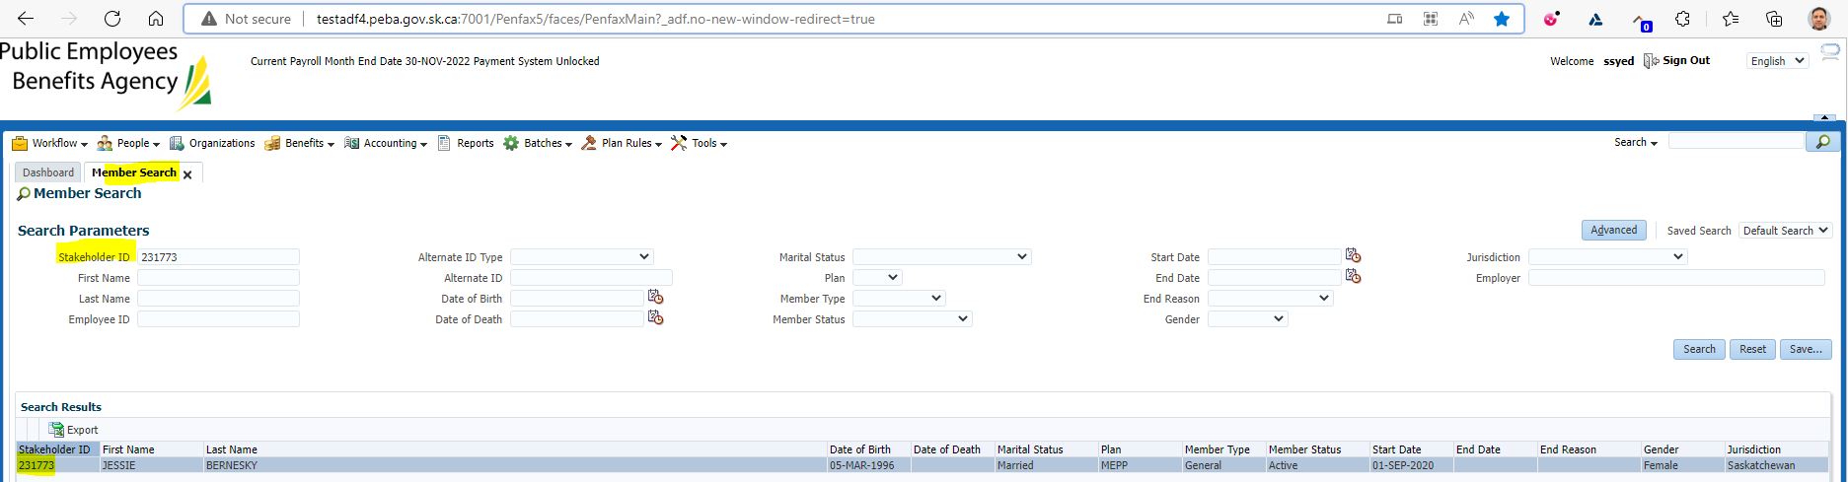

Click on Retirement Projection tab

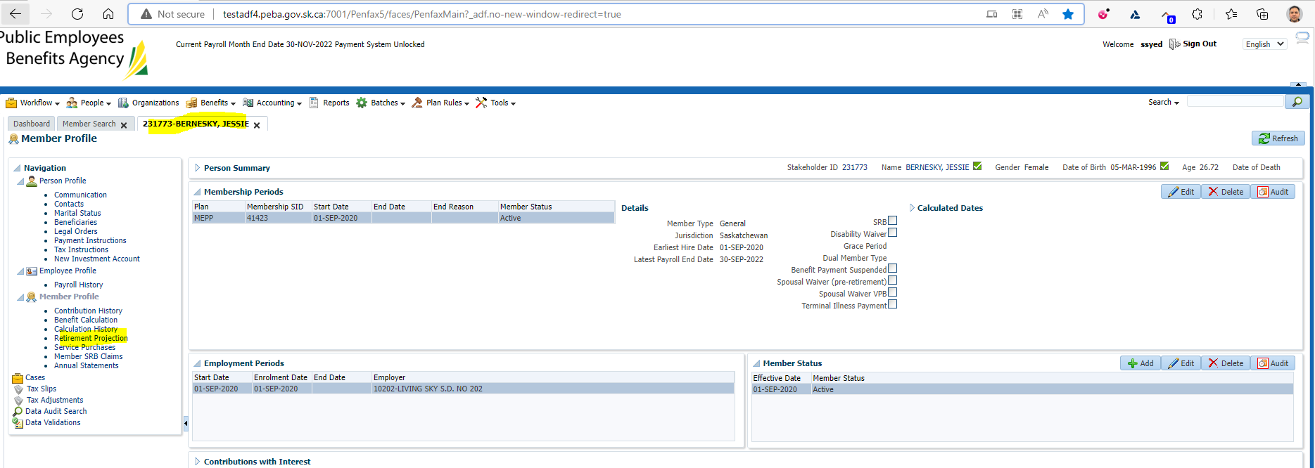

Click on Calculate Retirement Dates

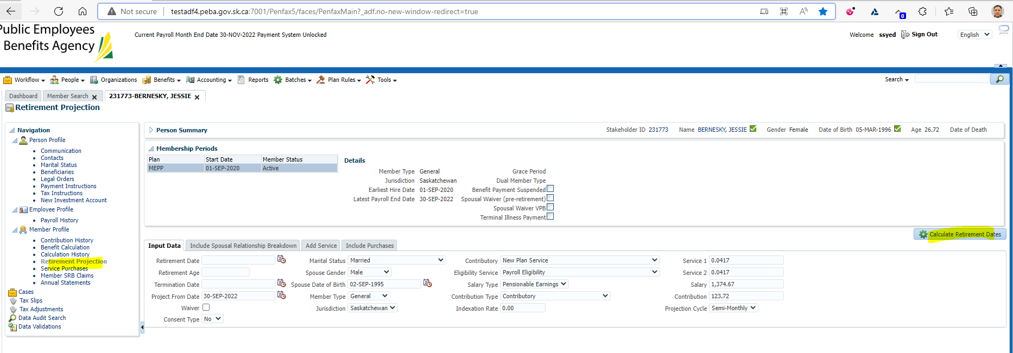

Click on Quote

Make sure it has tick mark on the Quote button under Retirement Dates

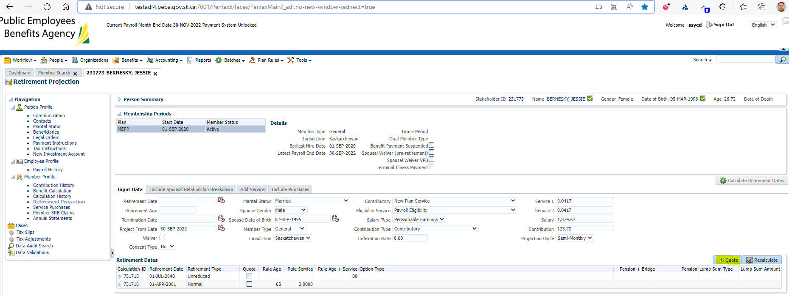

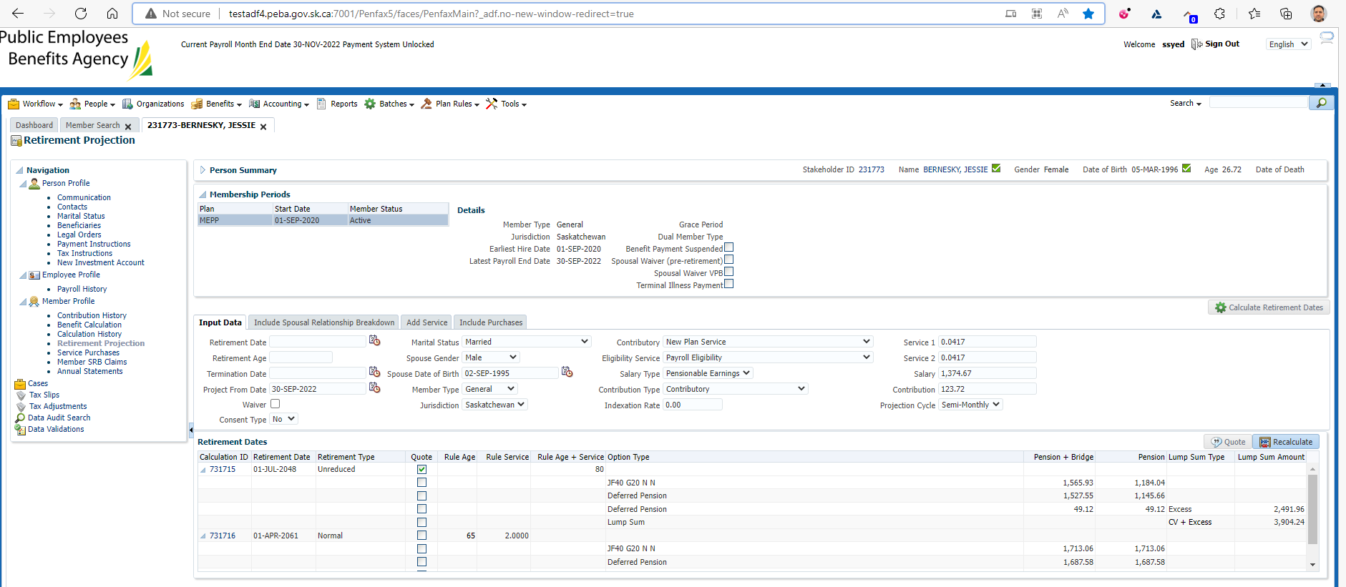

Comparison with Test1 region

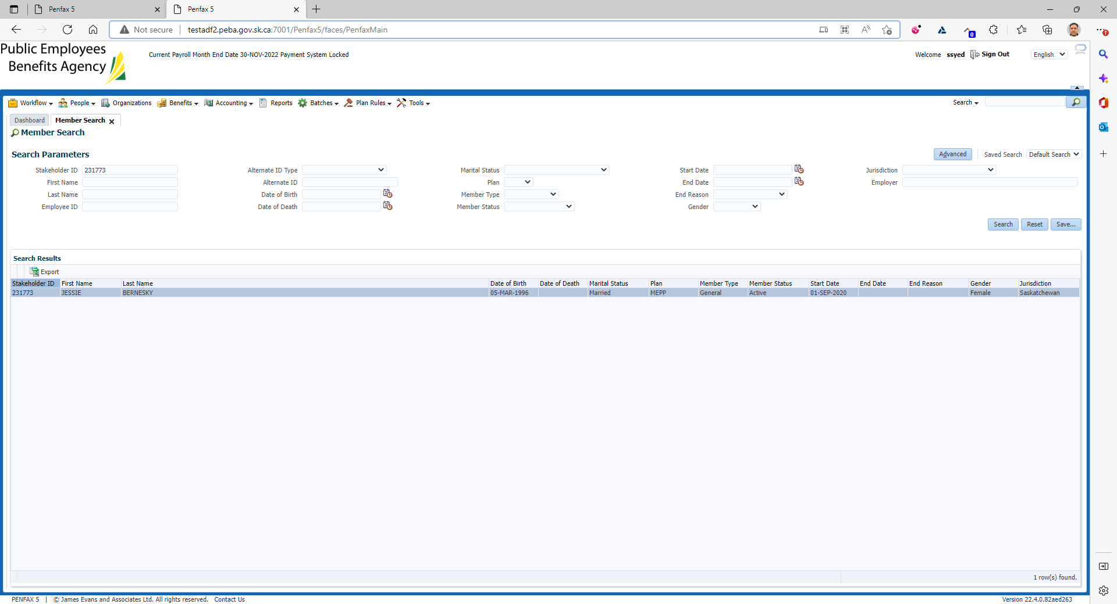

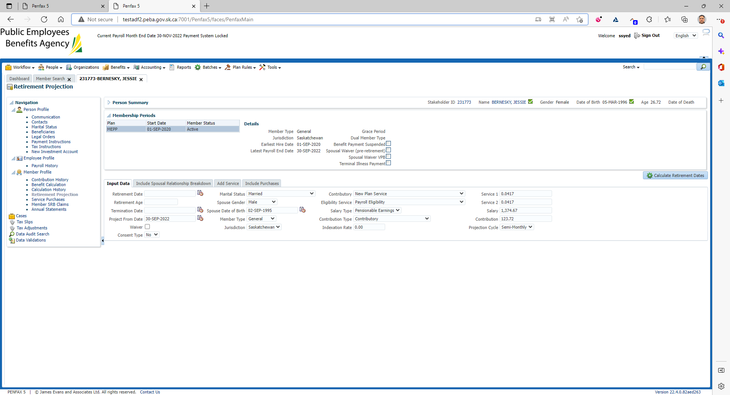

Click on Calculation Retirement Dates

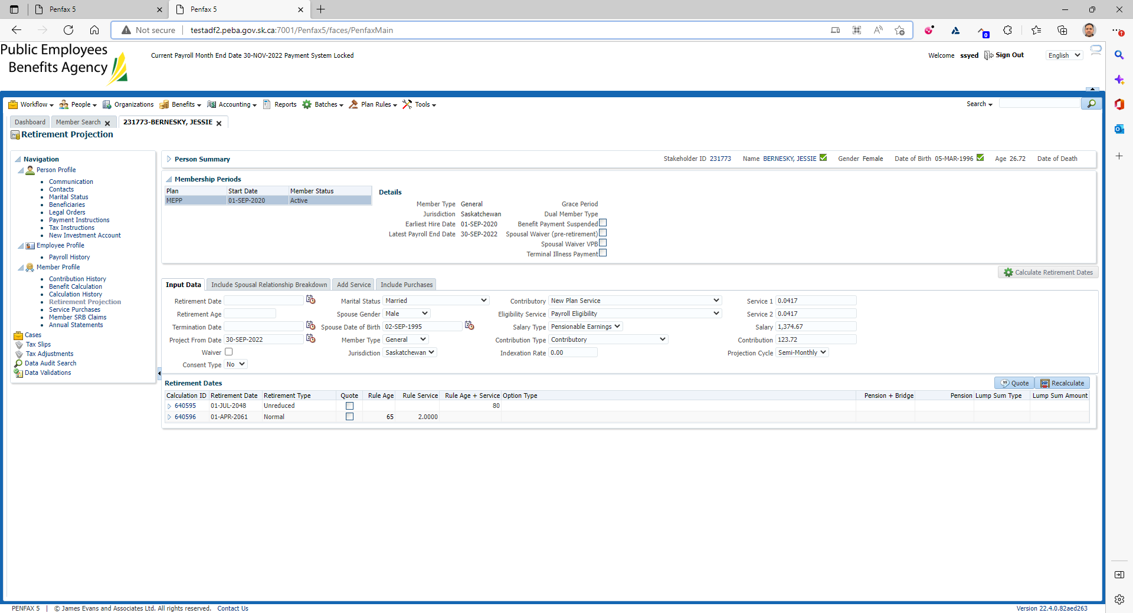

Click on Quote

Make sure it has tick mark on the Quote button under Retirement Dates

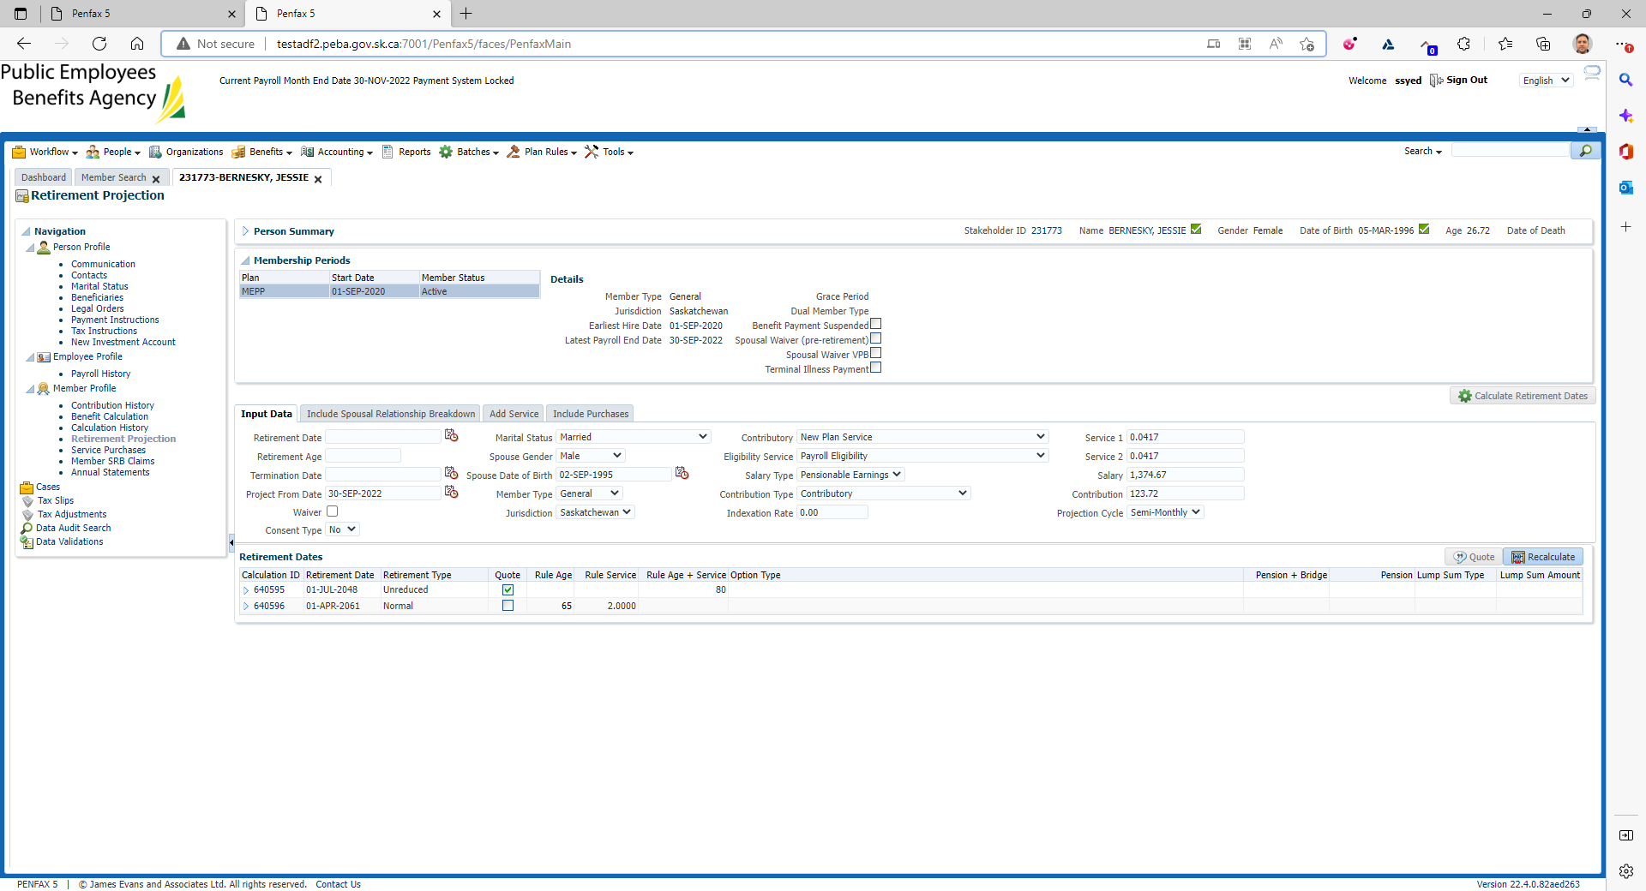

Comparison with Test 1 Region

